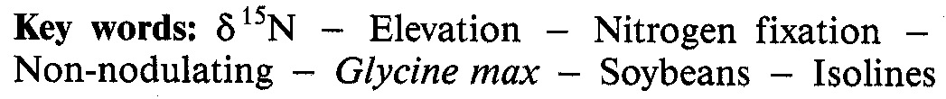
Biol Fertil Soils (1993) 15:81-86
The use of nitrogen-15 natural abundance and nitrogen yield of non-nodulating isolines to estimate nitrogen fixation by soybeans (Glycine max L.) across three elevations
Thomas George¹, Paul W. Singleton¹, and Chris van Kessel ²

¹ NifTAL Project, Department of Agronomy and Soil Science, University of Hawaii, 1000 Holomua Avenue, Paia, HI 96779, USA ²Department of Soil Science, University of Saskatchewan, Saskatoon, Canada S7N OWO
Biology and Fertility

Of Soils

© Springer-Verlag 1993
Received April 2, 1992
Summary. Dissimilarities in soil N uptake between N₂fixing and reference non-N₂-fixing plants can lead to inaccurate N₂ fixation estimates by N difference and ¹⁵N enrichment methods. The natural ¹⁵N abundance (δ¹⁵N) method relies on a stabilized soil ¹⁵N pool and may provide reliable estimates of N₂ fixation. Estimates based on the δ ¹⁵N and differences in N yield of nodulating and non-nodulating isolines of soybean were compared in this study. Five soybeans from maturity groups 00, IV, VI, and VIII and their respective non-nodulating isolines were grown at three elevations differing in ambient temperature and soil N availability. Despite large differences in phenological development and N yield between the non-nodulating isolines, the δ ¹⁵N values measured on seeds were relatively constant within a site. The δ ¹⁵N method consistently produced lower N2 fixation estimates than the N difference method, but only in three of the 15 observations did they differ significantly. The average crop N derived from N₂ fixation across sites and maturity groups was 81 % by N difference compared to 71 % by δ¹⁵N. The magnitude of difference between the two methods increased with increasing proportions of N derived from N2 fixation. These differences between the two methods were not related to differences in total N across sites or genotypes. The low N2 fixation estimates based on δ¹⁵N might indicate that the nodulating isolines had assimilated more soil N than the nonnodulating ones. A lower variance indicated that the estimates by N difference using non-nodulating isolines were more precise than those by δ ¹⁵ N. Since the differences between the estimates were large only at high N₂ fixation levels (low soil N availability), either method may be used in most situations when a non-nodulating isoline is used as the reference plant. The δ ¹⁵N method may have a comparative advantage over N difference and ¹⁵N enrichment methods in the absence of a suitable non-N₂-fixing reference plant such as a non-nodulating isoline.

Journal Series no. 3750 of the Hawaii Institute of Tropical Agriculture and Human Resources
Correspondence to: T. George
Knowledge of the amounts of N₂ fixed by the legume-Rhizobium spp. symbiosis and crop removal of soil N are essential for the optimal exploitation of the N₂-fixing process to improve crop system productivity. Of the many techniques that have been used to provide measures of N2 fixation by legumes, there is no single method suited for all field conditions (Peoples et al. 1989; Peoples and Herridge 1990). Each technique has its own unique advantages and limitations.
Estimates of N₂ fixation from differences in total N between N₂-fixing and non-N₂-fixing reference plants are yield-dependent and assumes similar amounts of soil N uptake by the N₂-fixing and the reference plants. Accuracy of the ¹⁵N isotope enrichment method is assumed to be yield-independent (Fried and Broeshart 1975) and to provide reliable estimates of N₂ fixation when the N₂-fixing and non-N₂-fixing plants sample the same soil N pool over time. However, ¹⁵N enrichment of the soil N pool declines from the time the isotope is applied. Differences in N uptake patterns between the N₂-fixing and non-N₂-fixing plants can therefore lead to inaccurate estimates (Witty 1983).
A stabilized soil ¹⁵N pool eliminates the problem of declining ¹⁵N enrichment of the available soil N pool. Allowing sufficient time for the incorporated ¹⁵N to equilibrate with native soil N would be a good strategy in the measurement of N₂ fixation. Pareek et al. (1990) observed that ¹⁵N dilution estimates of N₂ fixation by Sesbania spp. in a flooded lowland rice soil usini5 different reference plants gave similar estimates when SN was allowed to equilibrate. Under most field conditions the time required to approach equilibrium is expected to be long, and hence impractical. In addition, a long equilibration time can lead to substantial loss of applied N.
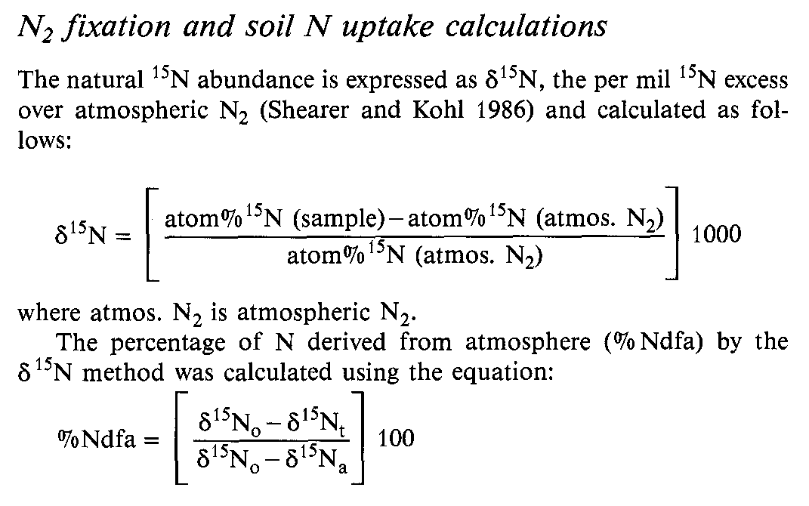
82
Many soils have a ¹⁵N natural abundance (δ¹⁵ N) that is significantly greater than the atmosphere and can be used to estimate N2 fixation (Delwiche and Steyn 1970; Shearer and Kohl 1986; Peoples and Herridge 1990). Soils with stable and sufficiently high δ¹⁵N values can provide credible N₂ fixation estimates since differences in the pattern of soil N uptake by N₂-fixing and non-N₂-fixing plants is no longer a major factor influencing the estimate. The reports on the reliability of the δ ¹⁵N method in measuring N₂ fixation are inconsistent. Problems can arise due to spatial and temporal variability in the level of δ ¹⁵N of available soil N (Turner et al. 1987; Bremer and van Kessel 1990), although sampling strategies can be developed to minimize the effect (Peoples et al. 1991). More serious errors result from variability during analysis by isotope fractionation and N losses during sample processing (Peoples et al. 1989), and lack of precision in measuring small differences in δ¹⁵N (Bremer and van Kessel 1990). Several soils have been reported to be relatively uniform in δ¹⁵N levels with depth and time, facilitating accurate N₂ fixation measurements (Bergersen et al. 1989; Peoples et al. 1991). Observing proper precautions during sample analysis and the use of modern precise mass spectrometers equipped with dual or triple collectors (Ledgard and Peoples 1988; Bremer and van Kessel 1990), therefore, can potentially provide reliable estimates of N₂ fixation using δ¹⁵N procedures.
In the present study, we compared N difference and δ¹⁵N methods for measuring N₂ fixation by nodulating soybeans using non-nodulating isolines as the nonN₂-fixing reference plants. We used genotypes from a range of soybean Maturity Groups and their respective non-nodulating isolines grown in three sites on an elevational transect on the island of Maui, Hawaii. This study was part of a larger investigation which dealt with effects of elevation, soil type, soil N, and genotype on rhizobial competition and nodulation; growth, yield, N uptake, and N₂ fixation; and phenology of soybean isolines (George et al. 1987, 1988, 1990).
Materials and methods

Experimental plan

Five nodulating soybean genotypes and their respective non-nodulating isolines from four Maturity Groups were grown at three sites differing mainly in mean temperature and soil N availability on the island of Maui, Hawaii ('Fable 1). The three sites were on an elevational transect within the same latitude which received similar rainfall and irradiance. At each site, the five genotypes and their respective isolines were assigned in a random complete block design with three replicates.

Field and plant culture

Procedures followed for soil amendment, rhizobial inoculation, and plant culture have been described previously (George et al. 1987). The fields, which were under grass vegetation, were tilled to a depth of 40 cm after removal of all above-ground grass residues a month before the start of the experiment. The soils were amended with lime to equalize pH between sites. Nutrients other than N were applied at maximum fertility levels. Seeds of soybean maturity groups 00 (Clay, nodulating and non-nodulating), IV (Clark, nodulating and non-nodulating), VI (D68-0099, nodulating; D68-0102, non-nodulating; N77-4262, nodulating, indeterminate;
and N77-4273, non-nodulating, indeterminate), and VIII (Hardee, nodulating and non-nodulating) were planted at all three sites on 29 July 1985. Seeds were sown in four rows 60 cm apart in 2.4- by 4.0-m plots to give a final population of 400000 plants ha-1. Fields were maintained at field capacity through drip irrigation throughout the experiment period.

Sampling and analytical procedures

Details of field harvest procedures, dry weight determination, and total N analysis have been described elsewhere (George et al. 1988). Plants were harvested at physiological maturity. Each nodulating isoline was harvested along with its non-nodulating isoline. Details of procedures followed for 15N analysis have been given by Bremer and van Kessel (1990). Ground seed samples were predigested in a 570 KMn04/50070 HZS04/reduced Fe mixture to recover N0₃ and NO2 during Kjeldahl digestion. Kjeldahl digests were steam-distilled and evaporated to dryness at a constant temperature of 60 °C in a forced-air oven used exclusively for δ 15N samples. Evaporated distillates were analyzed in an isotopic ratio mass spectrometer.

Determination of ISN natural abundance of fixed N2

All five nodulating isolines used in the field study were grown in the greenhouse to determine the ¹⁵N natural abundance of fixed N₂. The seeds were inoculated with the same inoculant strains as in the field and sown in vermiculite in pots watered with N-free nutrient solution (Singleton 1983). Plants were thinned to two per pot 10 days after germination and were grown to maturity. There were four replicates arranged in a completely random design. Seeds were harvested at physiological maturity and analysed for ¹⁵N following the same procedure as the field samples.
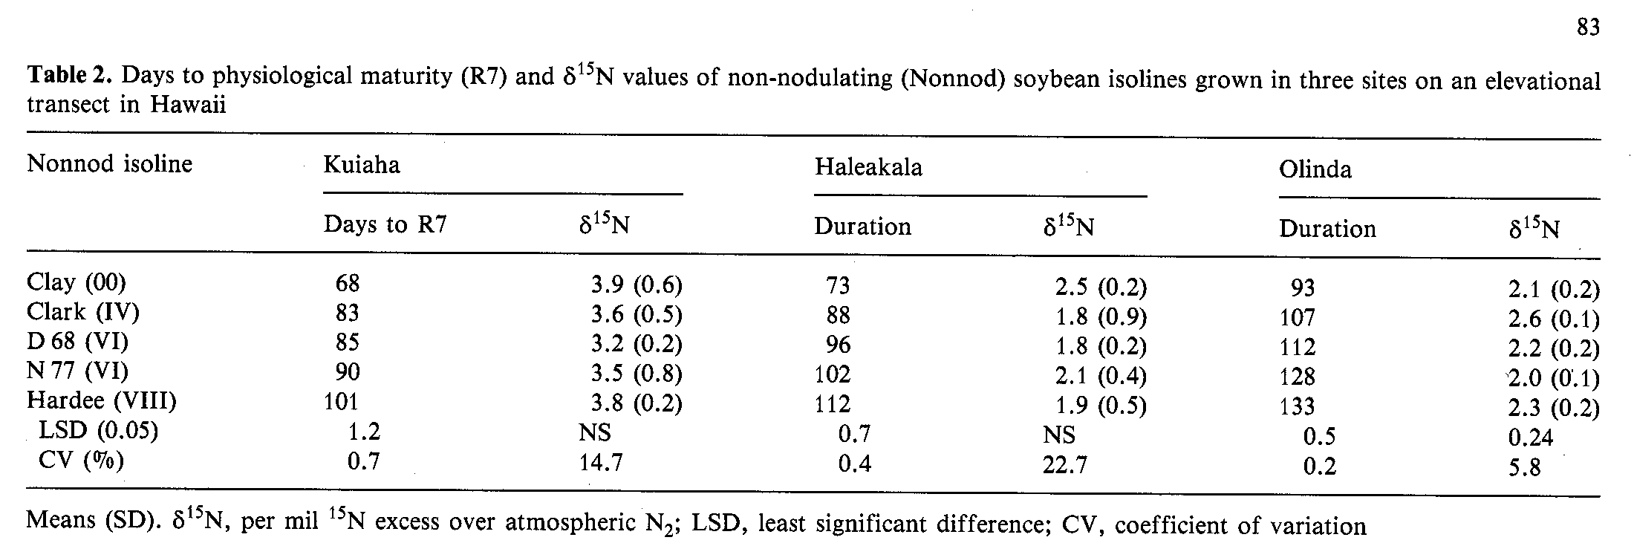
Results and discussion
The differences in soil N availability and ambient temperatures between sites and a range of soybean maturity groups were used to vary soil N uptake and N2 fixation in this study. The KCl-extracted soil N and mean temperature varied substantially between sites (Table 1). As reported earlier (George et al. 1988), the sites were associated with large differences in growth and N yield of both nodulating and non-nodulating isolines. The nodulating and non-nodulating isolines were similar in phenological development except for physiological maturity (George et al. 1990).
The δ¹⁵N values determined on seeds were not significantly different between non-nodulating isolines at the lowest and intermediate elevations (Table 2). At the highest site, three of the five isolines had similar δ¹⁵N values. The δ¹⁵N values of the non-nodulating isolines differed among sites and ranged from an average of 2.0 at the intermediate site to 3.6 at the lowest site. Considering the differing durations (Table 2) and the differences in N yield among non-nodulating isolines (George et al. 1988), the differences in δ¹⁵N values within a site are negligible. Even at the highest site where the δ¹⁵N values differed statistically, the growth durations of three isolines with similar 8¹⁵N ranged from 93 to 133 days. The δ¹⁵N values of the five maturity groups were thus relatively constant within a site. The relatively constant δ¹⁵N value of the non-nodulating isolines within a site suggest that the natural ¹⁵N abundance of the available soil N might not have changed significantly with time during the experiment. Similar observations have been reported elsewhere (Ledgard et al. 1984; Bergersen et al. 1989; Peoples et al. 1992).
The δ¹⁵N method estimated lower N2 fixation than the N difference method (Table 3) in the majority of observations. Average N derived from N2 fixation as estimated by the δ¹⁵N method was 9% lower than the N difference estimate, but was statistically significant only in 3 out of the 15 observations. Also, the estimates by the two methods were positively correlated (Fig. 1). Reports comparing N difference and δ¹⁵N estimates of N2 fixation by soybeans in the field present varying conclusions;
where 815No is the seed 815N value of the non-nodulating reference plant, 815N2 is the seed 815N value of N in the N2-fixing plant, and 815Na is the seed 815N value of fixed N in the N2-fixing plant grown on N-free medium in the greenhouse (Shearer and Kohl 1986). The percentage of N derived from soil (olo Ndfs) was calculated using the equation:

% Ndfs = 100-% Ndfa.

The amount of N derived from the atmosphere by the N difference method was determined by subtracting the total N accumulation by the non-nodulating isoline from that of the N2-fixing isoline.

Statistical analysis

All data were subjected to analysis of variance. Estimates of N derived from N₂ fixation by N difference and δ15N methods were compared with paired t-tests.
84

the two methods give similar estimates (Kohl et al. 1980), the δ¹⁵N method estimates lower N2 fixation than the N difference (Wada et al. 1986), and the δ¹⁵N method estimates higher N2 fixation than the N difference (Amarger et al. 1979). The conflicting findings are probably due to differences in soil N, relative N uptake by the N2-fixing; soybeans, and the reference or variability in soil δ¹⁵N. In the present study, the differences between the two methods in some instances are relatively great, but not statistically significant, due to a large variance associated with the δ¹⁵N estimates.
Since the δ¹⁵N estimates of N2 fixation were lower than the N difference estimates, it is unlikely that isotopic fractionation influenced the estimates which were based on seed δ¹⁵N. Moreover, 85% of the total N measured at harvest was found in the seed, which is higher than the δ¹⁵N estimates of total N2 fixed at all sites (Table 4). The data of Shearer et al. (1980) indicated that the atom % ¹⁵N of seeds of N2-fixing soybeans represented most accurately the value for atom % ¹⁵N of the whole plant. Accordingly, Kohl et al. (1980) and Bergersen et al. (1985) have reported no significant differences between estimates of N2 fixation based on δ¹⁵N of whole plant or seeds. Other soybean studies, however, have observed
considerable tissue variation in δ¹⁵N (Peoples et al. 1991), or have found that when N2 fixation is prolonged late into seed-filling, preferential assimilation of the newly fixed N can lead to a different seed δ¹⁵N content to that of the shoot or whole plant (Bergersen et al. 1989; 1992). This might explain some of the variability in estimates of N2 fixation in the present study by δ¹⁵N.
In evaluating the two methods, it is prudent to note how closely the methods distinguished N2 fixation capacities of genotypes within and across sites. Both methods estimated the highest and the lowest proportions of N derived from N2 fixation at the highest and the lowest sites, respectively (Table 5), corresponding to the extractable soil N levels (Table 1). The differences in N2 fixation estimates between the two methods were not related to the differences in total N assimilation among sites or among genotypes (Table 5, 6). Further, by either method, the average percentage of N derived from N2 fixation was similar among genotypes despite large differences in total N. Although the N2 fixation estimates based on δ¹⁵N of seeds could be less precise, due to a larger variance associated with this method than with the N difference estimates, both methods prove useful in comparing N2 fixation by soybean genotypes within and across environments. The differences between
the two methods were generally larger with higher proportions of N derived from N2 fixation (Fig. 1). It is likely that the differences between the two methods were greatest at the highest site (Table 3) because of the severely restricted growth and N uptake by the non-nodulating isolines (George et al. 1988). Thus, the estimates based on δ¹⁵N may be more realistic at the highest site since they are yield-independent. Estimates of N2 fixation were similar at the intermediate site, which had the highest extractable soil N and where the proportion of N derived from N2 fixation estimated by N difference was the lowest. Thus, soil N availability becomes an important factor to be considered in comparing δ¹⁵N and N difference methods of estimating N2 fixation.
Soil N uptake by the nodulating isolines calculated from the δ¹⁵N data was substantially higher than the actual N yield of non-nodulating isolines at two of the three sites ('Table 5) and for all genotypes (Table 6). At the highest site, δ¹⁵N estimates of soil N uptake were several-fold greater than the N yields recorded by the nonnodulating isolines, but this may reflect the influence of restricted soil N availability at this site (George et al. 1988). Under these conditions, the ability of the nonnodulating isolines to extract soil N might have been poorer than that of the more vigorously growing, nodulating isolines. At the intermediate site which had the highest extractable soil N (Table 1), estimates of soil N uptake predicted from δ¹⁵N for the nodulating isolines were similar to actual measurements in the nonnodulating isolines. Despite differing KCl-extractable N, the δ¹⁵N estimates of soil N uptake by nodulating isolines were similar at the lowest and the intermediate sites. These differences in soil N uptake by nodulating and non-nodulating plants across and within sites warrant a closer scrutiny in the use and interpretation of N difference and δ¹⁵N derived estimates of soil N uptake and N2 fixation.
Conclusions
15N natural abundance and N difference estimates of N₂ fixation were compared in five soybean genotypes (maturity groups 00, IV, VI, and VIII) grown at three sites differing in soil N availability and ambient temperature. In most cases the N difference and δ¹⁵N methods produced statistically similar estimates of N2 fixation despite an average 9% difference between the estimates. Across sites, δ¹⁵N values of non-nodulating isolines differed, but not across isolines within a site, indicating that δ¹⁵N values may have been relatively constant for the duration of the study. The differences in N2 fixation estimates between the two methods could have been mainly due to differences in soil N uptake between fixing and non-fixing isolines or to the analysis of only seeds for δ¹⁵ N. The proportions of N derived from N2 fixation, determined by either method, were similar across genotypes. The sites of highest and lowest N2 fixation were the same with both procedures. On the basis of the current study it would appear that both techniques could be equally useful in comparing N2
85

fixation capacities of soybean genotypes within and across environments when nonnodulating isolines are used as the non-N2-fixing reference. The N difference method, however, is an easier and more economical method because it does not require meticulous analytical procedures or sophisticated and expensive equipment. The δ¹⁵N method many have a comparative advantage over N difference and ¹⁵N enrichment methods when the non-N₂-fixing reference is not a nonnodulating isoline.

Acknowledgments. This research was supported in part by the U.S. Agency for International Development grant DAN-4177-A-00-1077-00 (Improved biological nitrogen fixation through biotechnology-NifTAL). Conclusions of this paper do not necessarily reflect those of the granting agency. The authors acknowledge K. Keane and R. Koglin for their assistance in the field, G. Swerhone and G. Parry for carrying out the 15N analysis, and M. Peoples for providing comments on the manuscript.

References

Amarger N, Mariotti A, Mariotti F, Durr JC, Bourguignon C, Lagacherie B (1979) Estimate of symbiotically fixed nitrogen in field grown soybeans using variations in 15N natural abundance. Plant and Soil 52:269-280
Bergersen FJ, 'Ilxrner GL, Gault RR, Chase DL, Brockwell J (1985) The natural abundance of 15N in an irrigated soybean crop and its use for the calculation of nitrogen fixation. Aust J Agric Res 36:411-423
Bergersen FJ, Brockwell J, Gault RR, Morthorpe LJ, Peoples MB, 'Ibrner GL (1989) Effects of available soil nitrogen and rates of inoculation on nitrogen fixation by irrigated soybeans and evaluation of δ15N methods for measurement. Aust J Agric Res 40:763-780
Bergersen FJ, 'lbrner GL, Peoples MB, Gault RR, Morthorpe LJ, Brockwell J (1992) Nitrogen fixation during vegetative and reproductive growth of irrigated soybeans in the field: Application of 15N methods. Aust J Agric Res 43:145 -153
Bremer E, van Kessel C (1990) Appraisal of the nitrogen-15 natural-abundance method for quantifying dinitrogen fixation. Soil Sci Soc J 54:404-411
Delwiche CC, Steyn PL (1970) Nitrogen isotope fractionation in soils and microbial reactions. Environ Sci Technol 4:929-935
Fried M, Broeshart H (1975) An independent measurement of the amount of nitrogen fixed by a legume crop. Plant and Soil 43: 707-711
George T, Bohlool BB, Singleton PW (1987) Bradyrhizobium japonicum - environment interactions: Nodulation and interstrain competition in an elevational transect. Appl Environ Microbiol 53: 1113-1117
George T, Singleton PW, Bohlool BB (1988) Yield, and soil N uptake and nitrogen fixation by soybeans from four maturity groups grown at three elevations. Agron J 80:563-567
George T, Bartholomew DP, Singleton PW (1990) Effect of temperature and maturity group on phenology of field grown nodulating and nonnodulating soybean isolines. Biotronics 19:49-59
Kohl DH, Shearer G, Harper JE (1980) Estimates of N2 fixation based on differences in the natural abundance of 15N in nodulating and nonnodulating isolines of soybeans. Plant Physiol 66:61-65
Ledgard SF, Peoples MB (1988) Measurement of nitrogen fixation in the field. In: Wilson JR (ed) Advances in nitrogen cycling in agricultural ecosystems. Wallingford, UK, CAB International, pp 351-367
Ledgard SF, Freney JR, Simpson JR (1984) Variations in natural abundance of 15N in the profiles of some Australian pasture soils. Aust J Soil Res 22:155-164
Pareek RP, Ladha JK, Watanabe I (1990) Estimating N2 fixation by Sesbania rostrata and S. cannabina (syn. S. aculeata) in lowland rice soil by the 15N dilution method. Biol Fertil Soils 10:77-88
86
Peoples MB, Herridge DF (1990) Nitrogen fixation by legumes in tropical and subtropical agriculture. Adv Agron 44:155-223
Peoples MB, Faizah AW Rerkasem B, Herridge DF (1989) Methods for evaluating nitrogen fixation by nodulated legumes in the field. Australian Council for International Agricultural Research Monogr 1
Peoples MB, Bergersen FJ, 'Ilzrner GL, Sampat C, Rerkasem B, Bhromsiri A, Nuchayati DP, Faizah AW Sudin MN, Norhayati M, Herridge DF (1991) Use of the natural enrichment of 15N in plant available soil nitrogen for the measurement of symbiotic N2 fixation. In: Stable isotopes in plant nutrition, soil fertility and environmental studies. International Atomic Energy Agency, Vienna, pp 117-129
Peoples MB, Bell MJ, Bushby VA (1992) Effect of rotation and inoculation with Bradyrhizobium on nitrogen fixation and yield of peanut (Arachis hypogaea L., cv. Virginia Bunch). Aust J Agric Res 43:595 -607
Shearer G, Kohl DH (1986) N2 fixation in field settings: Estimates based on natural 15N abundance. Aust J Plant Physiol 13:699-756
Shearer G, Kohl DH, Harper JE (1980) Distribution of 15N among plant parts of nodulating and nonnodulating isolines of soybeans. Plant Physiol 66:57-60
Singleton PW (1983) Split-root growth system for evaluating the effect of salinity on the components of the soybean -Rhizobium japonicum symbiosis. Crop Sci 23:259-262
1lzrner GL, Gault RR, Marthorpe L, Chase DL, Bergersen FJ (1987) Differences in the natural abundance of 15N in the extractble mineral nitrogen of cropped and fallowed surface soils Aust J Agric Res 38:15-25
Wada E, Imaizumi R, Kabaya Y, Yasuda T, Kanamori T, Saito G, Nishimune A (1986) Estimation of symbiotically fixed nitrogen in field grown soybeans: An application of natural 15N/14N abundance and a low level 15N-tracer technique. Plant and Soil 93:269-286
Witty JF (1983) Estimating N2 fixation in the field using 15N-labelled fertilizer: Some problems and solutions. Soil Biol Biochem 15:631-639

